

**AMERICAN INTERNATIONAL UNIVERSITY–BANGLADESH (AIUB)**

**FACULTY OF SCIENCE & TECHNOLOGY**

**DEPARTMENT OF CSE**

# SOFTWARE QUALITY AND TESTING

**Session: Fall 2022-2023**

**Section: B**

**MID-ASSIGNMENT: 1**

**Course Teacher** :

**ABHIJIT BHOWMIK**

## Submitted By:

|  |  |  |
| --- | --- | --- |
| **NAME** | **ID** | **PROGRAM** |
| **MD. SAKIB HASAN MUBIN** | **19-40715-1** | **BSc CSE** |

Date of Submission: **November 07, 2022**

What we are doing in this Assignment?

1. Download and install Java SE Development Kit 19 on the device.
2. Download Eclipse, Selenium library and Chromedriver.
3. Test a project/ Module ( Use our previous project module) using Selenium.
4. Take snapshots of every step starting from the Selenium setup.

**Setup process of Selenium:**

**Flowchart of Testing process:**

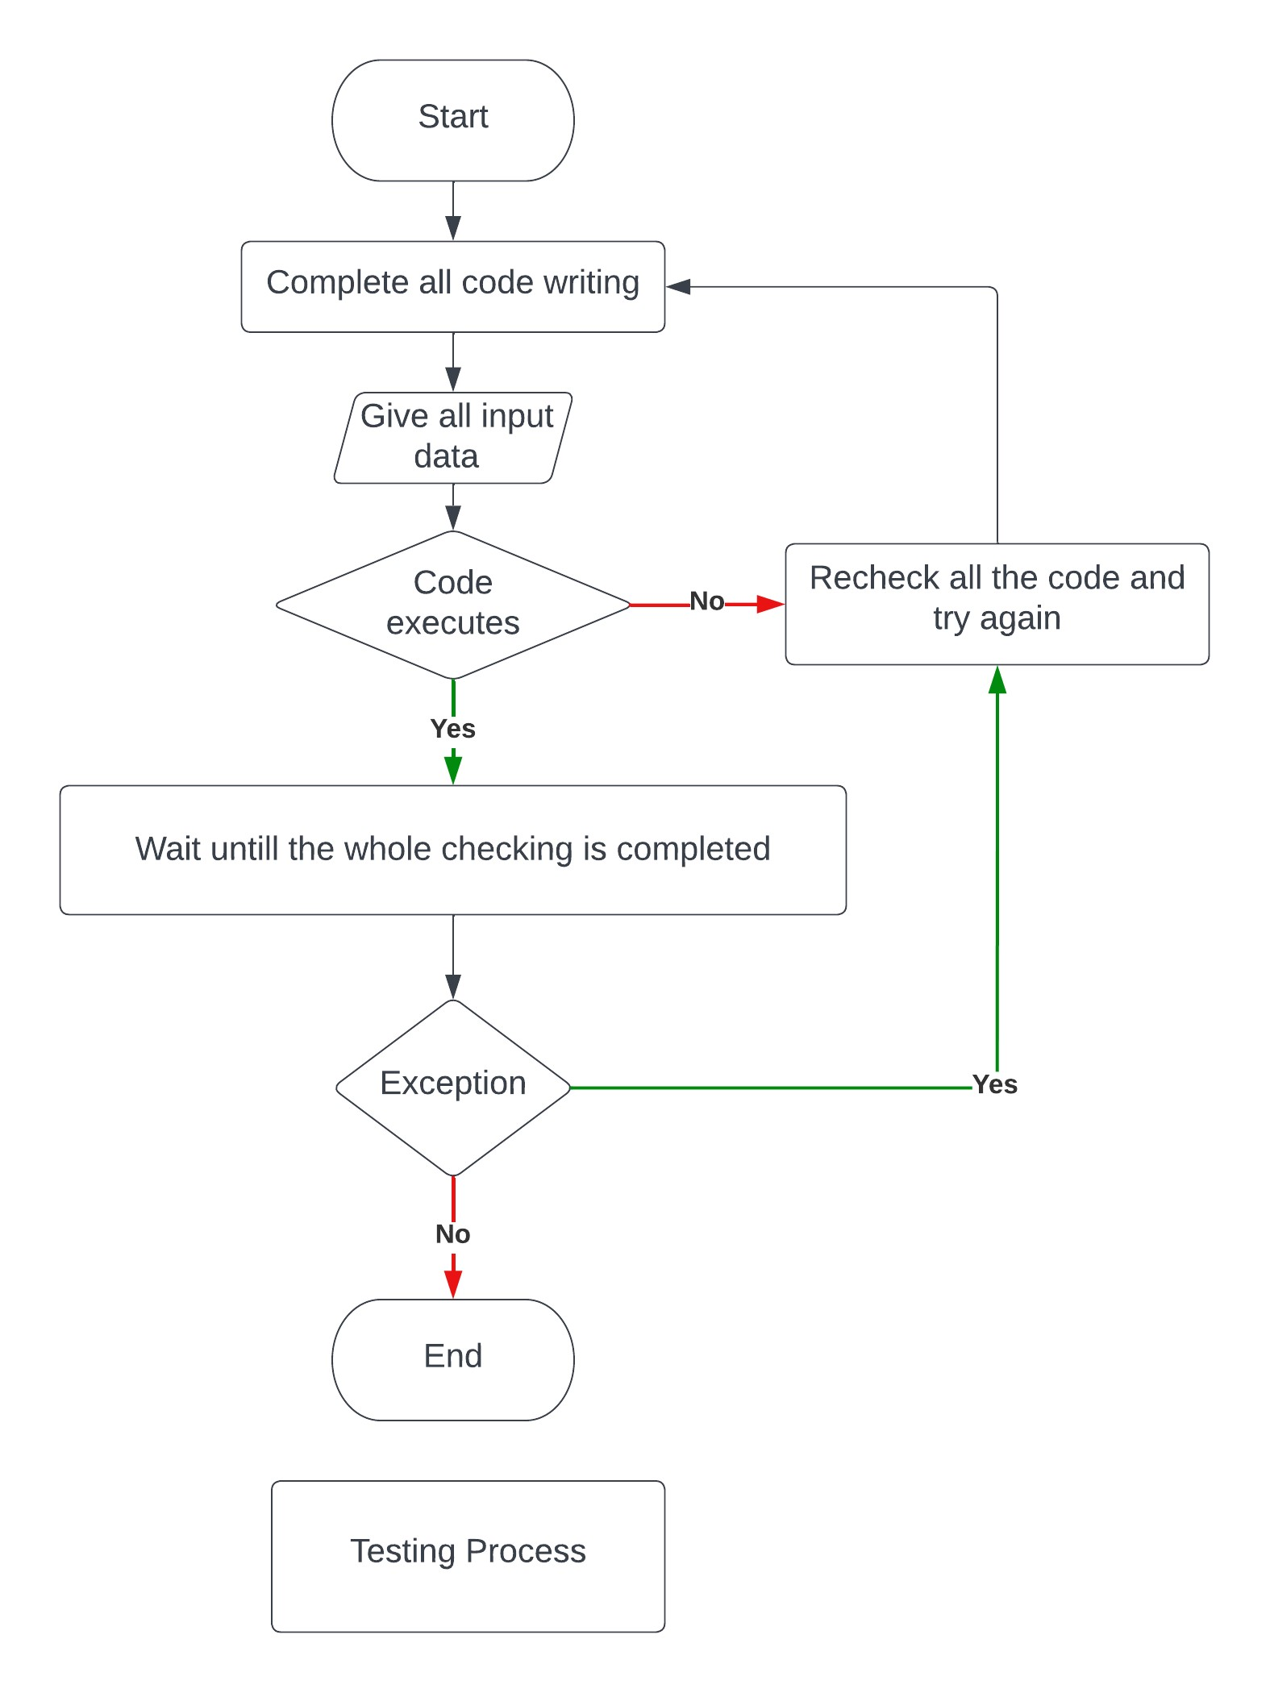

**Snapshots of every step starting from the Selenium setup:**

1. Download and install Java SE Development Kit 19 on the device:

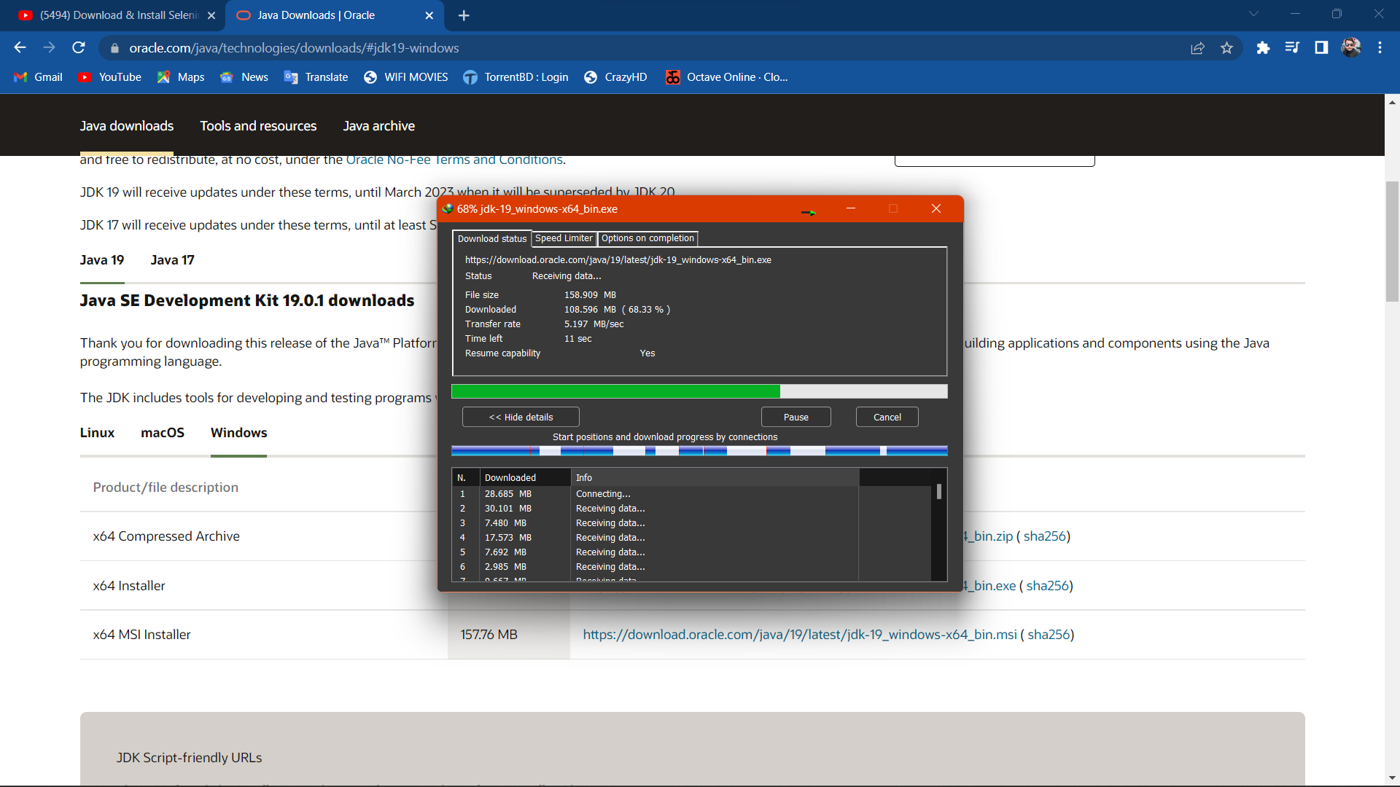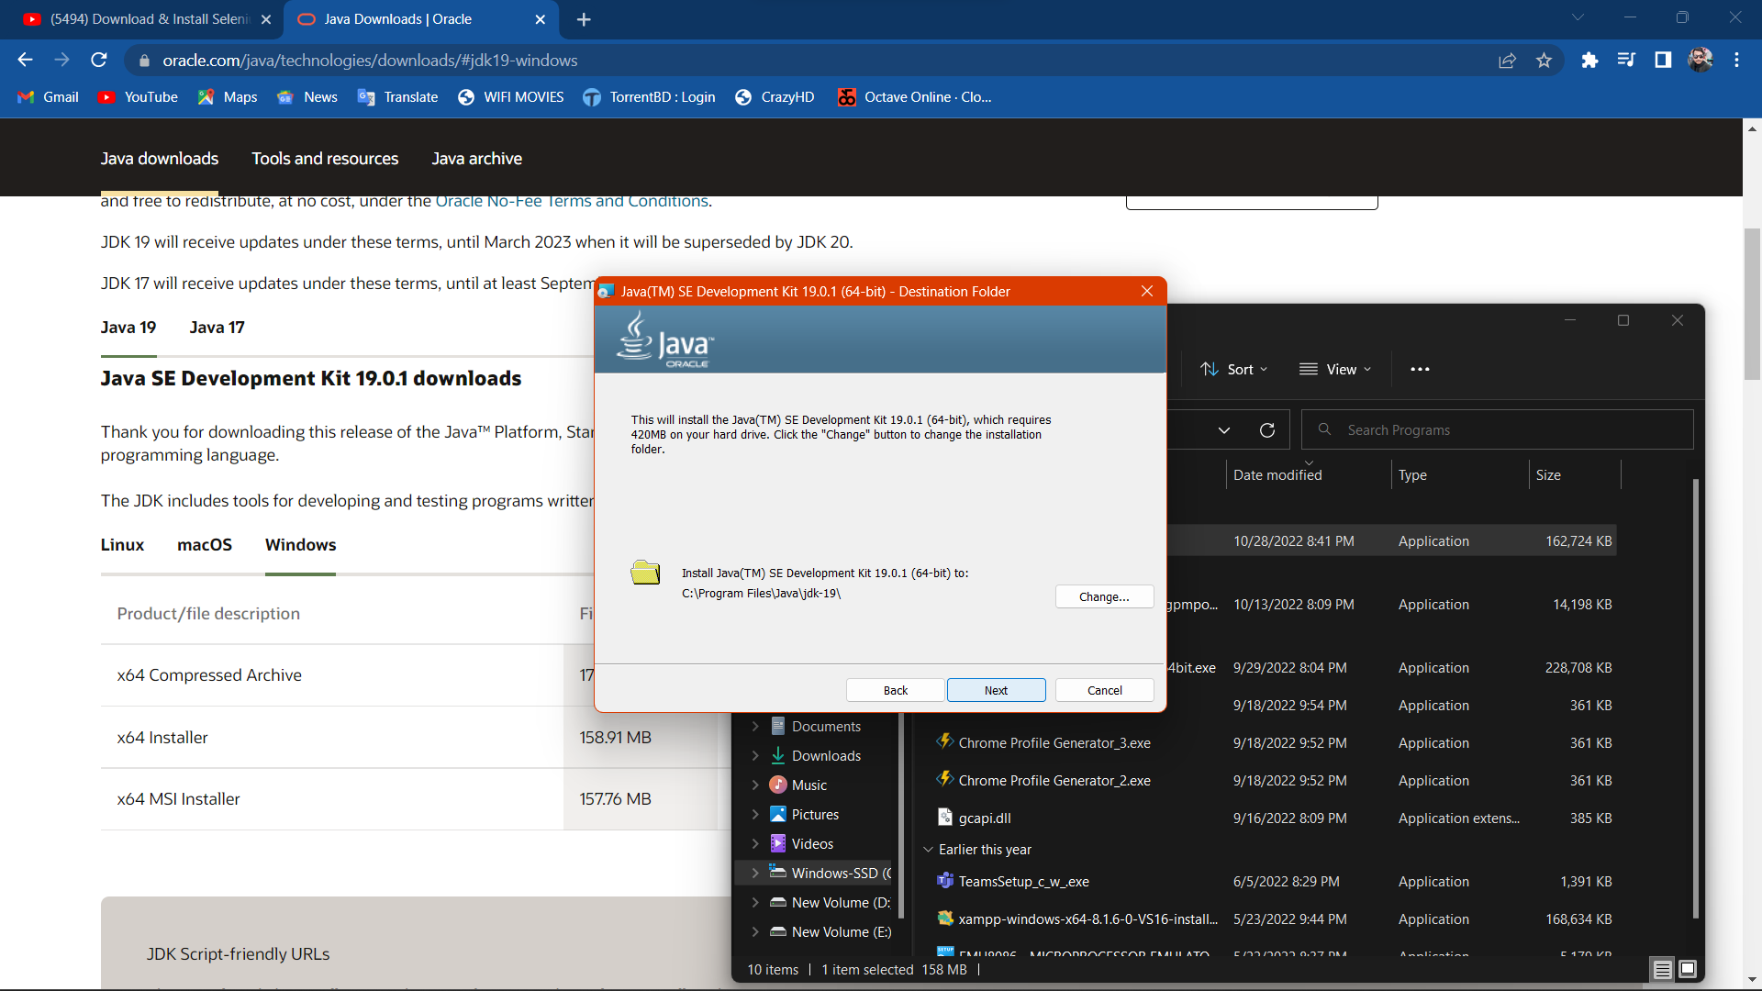

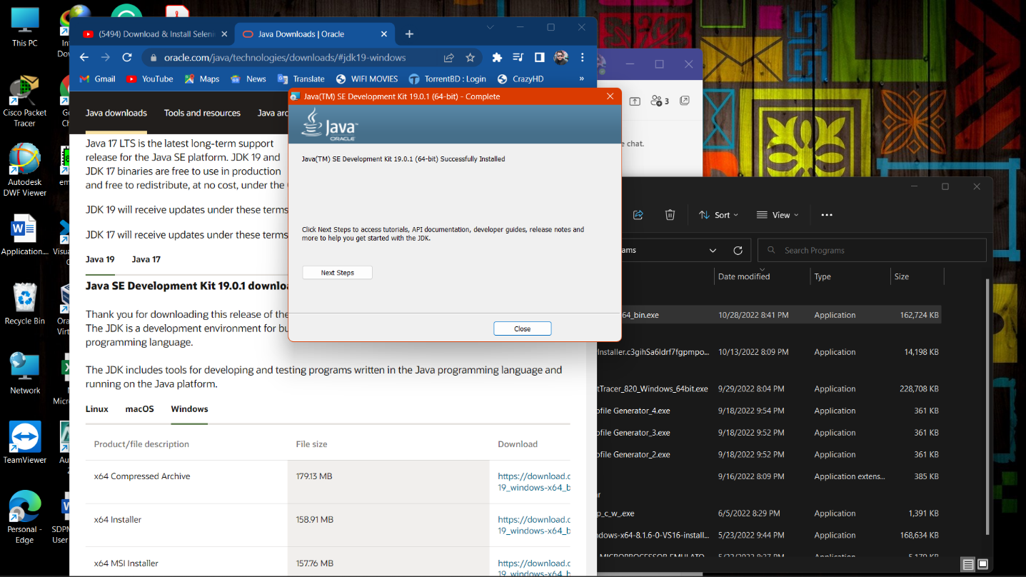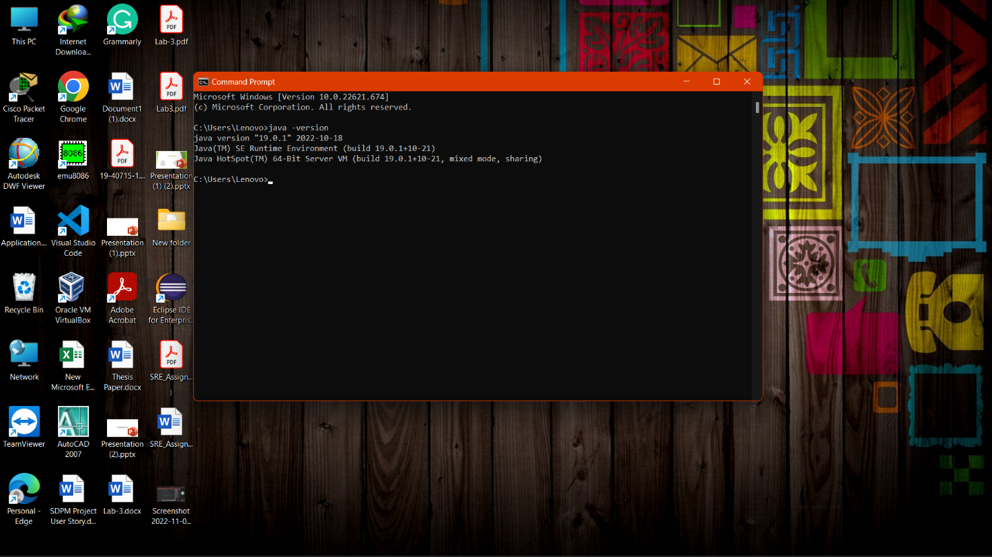

2. Download Eclipse, Selenium library and Chromedriver:

i. Download Eclipse installation:

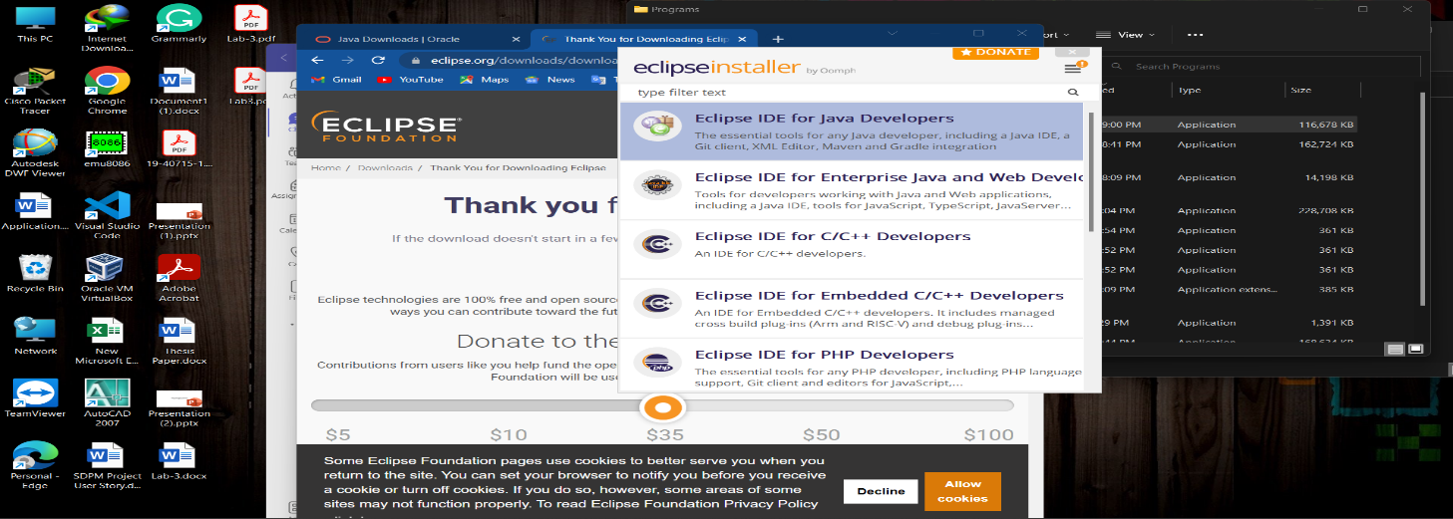

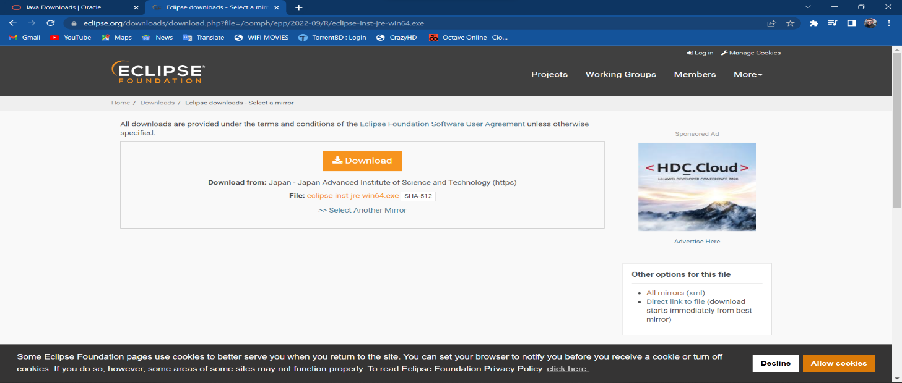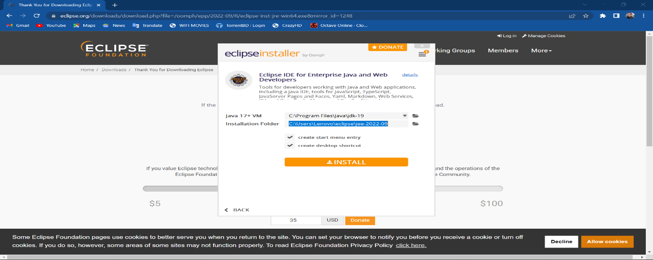

ii. Download Selenium library & ChromeDriver:

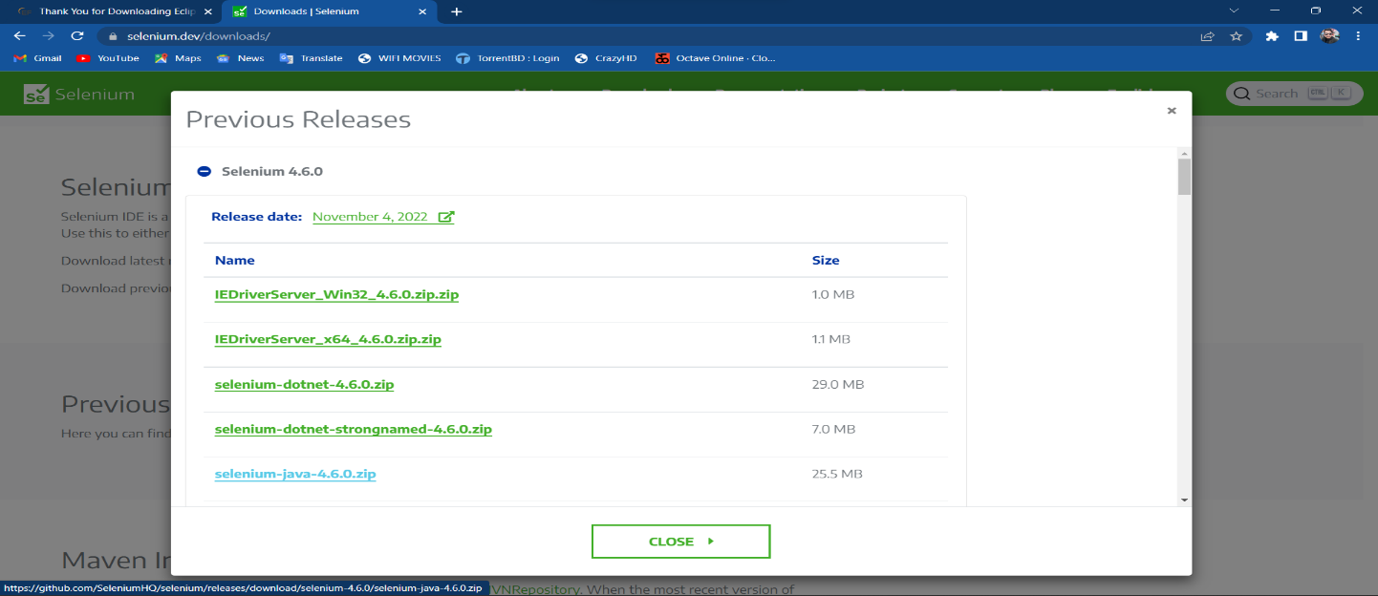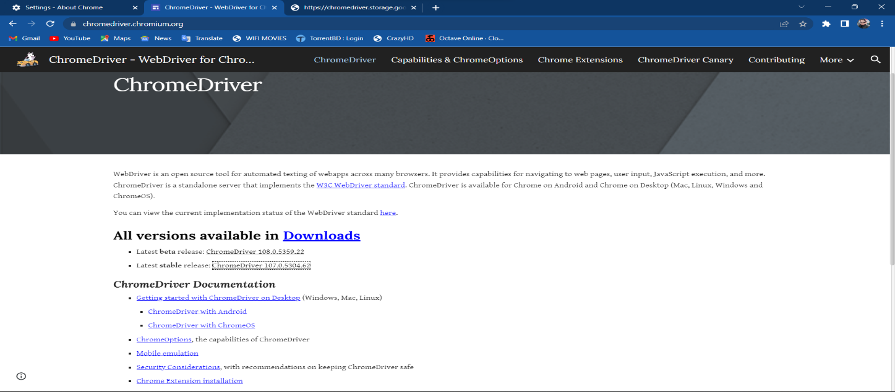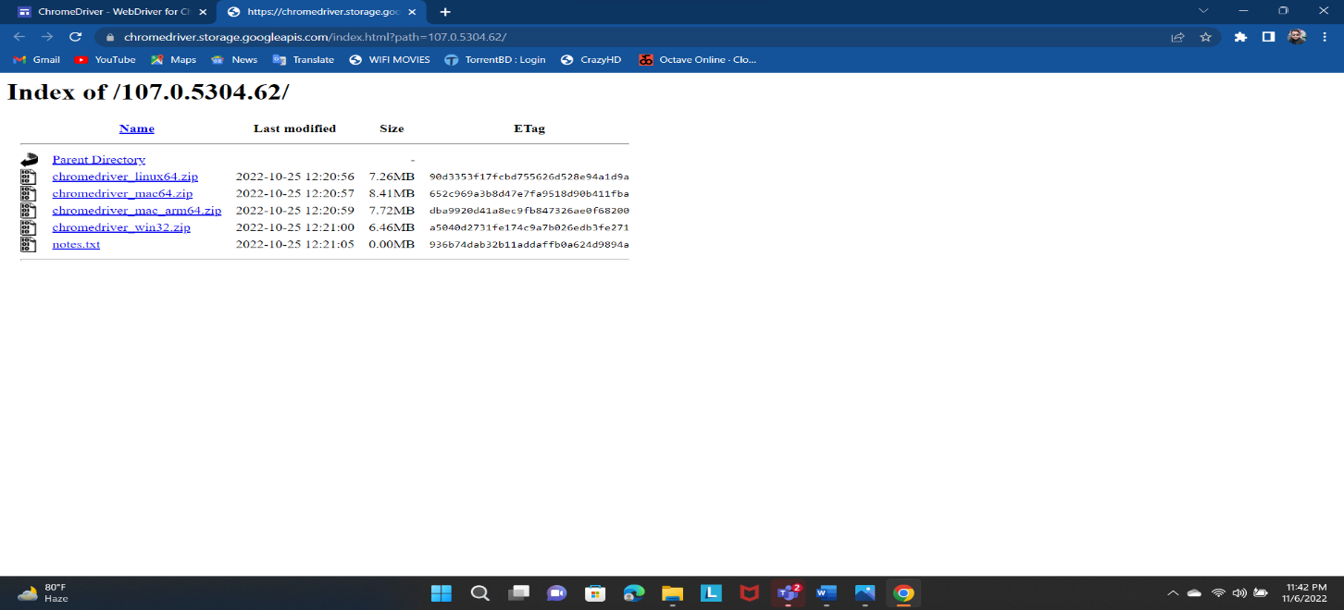

3. Test a project/ Module by using Selenium:

i. Creating workspace and project on eclipse:

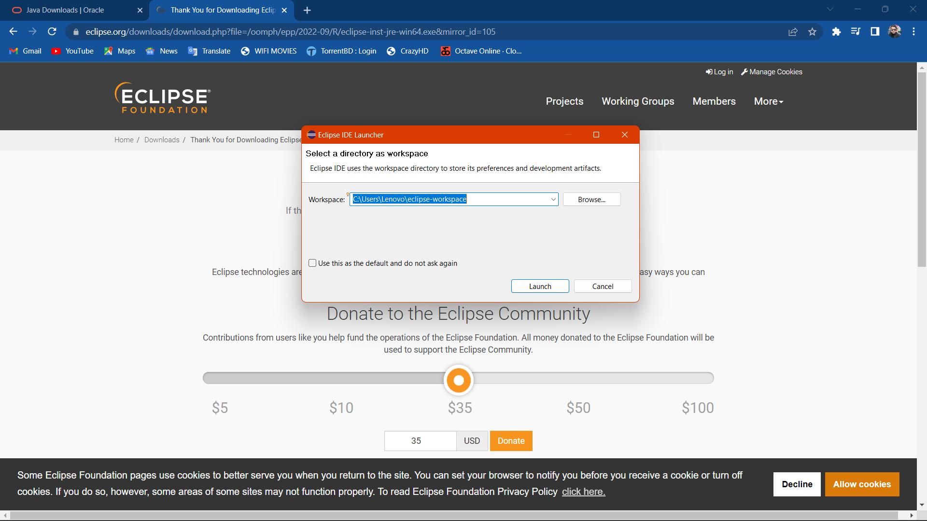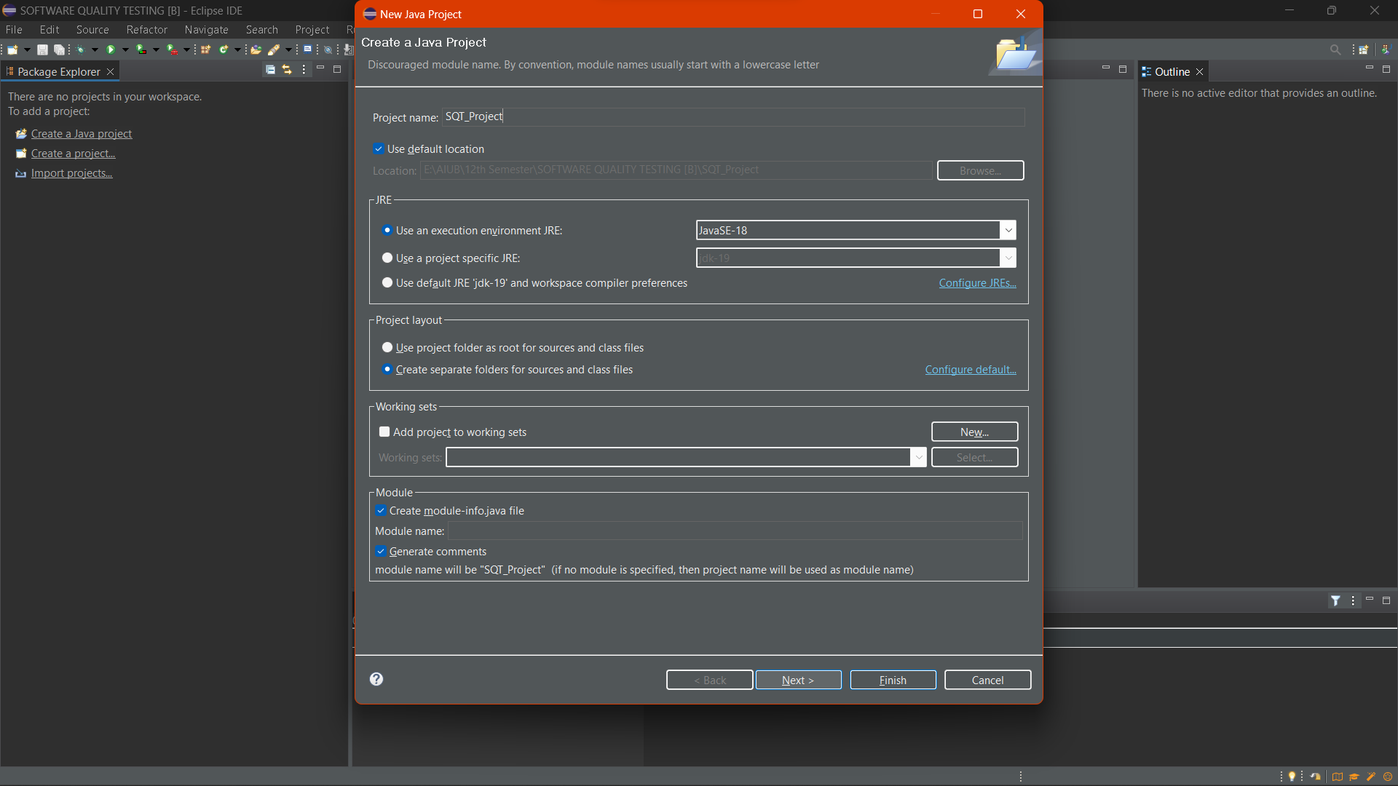

ii. Add all Selenium external JAR files into JAVA build path:

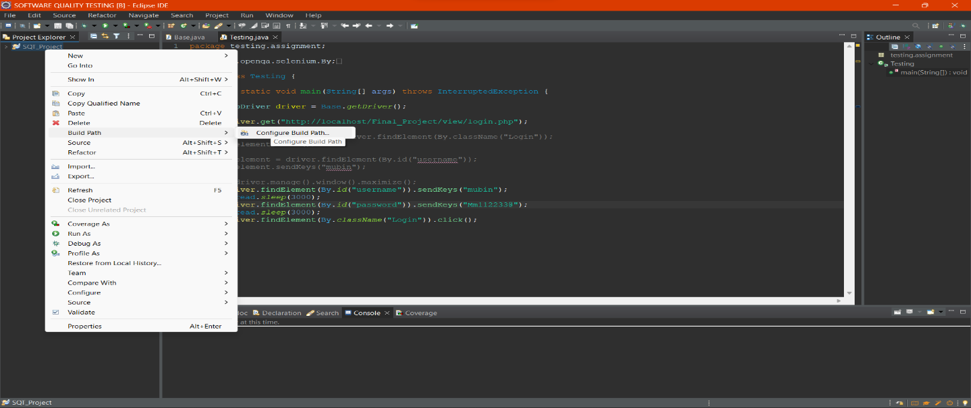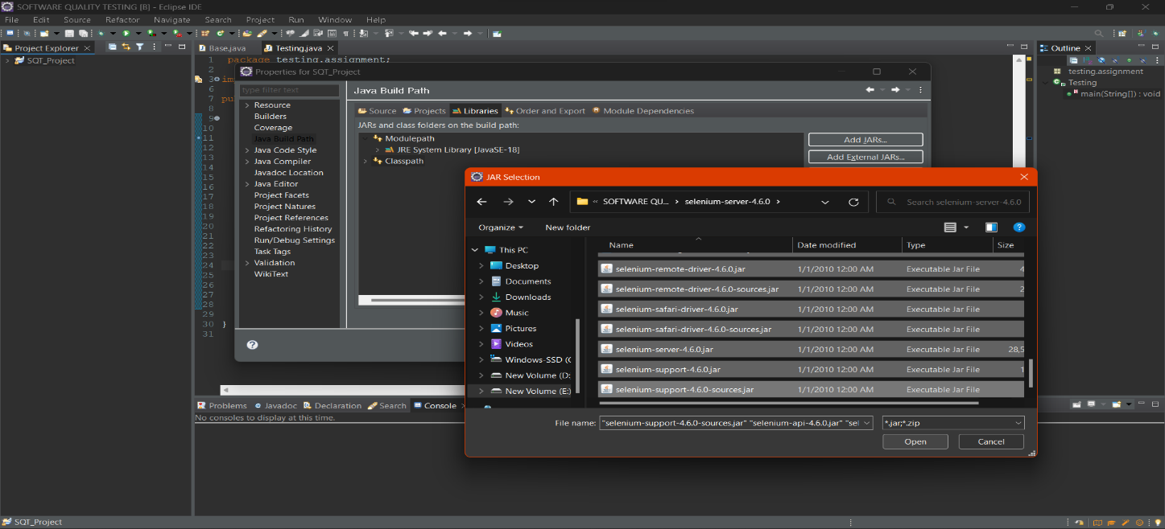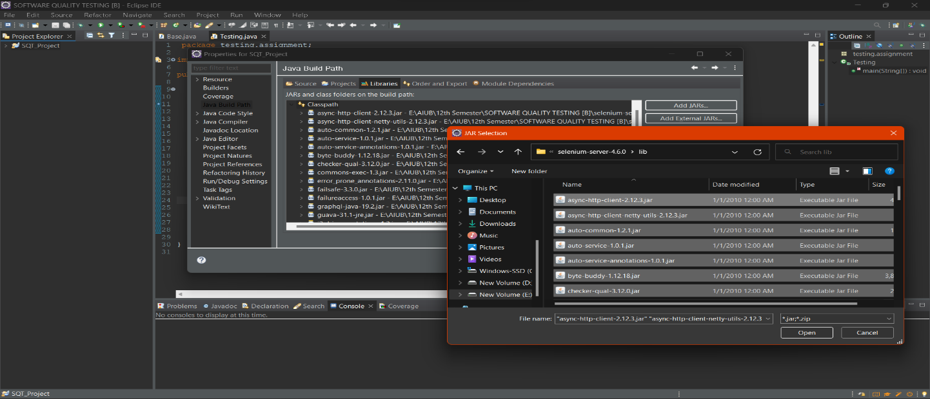

iii. Creating Package & Class:

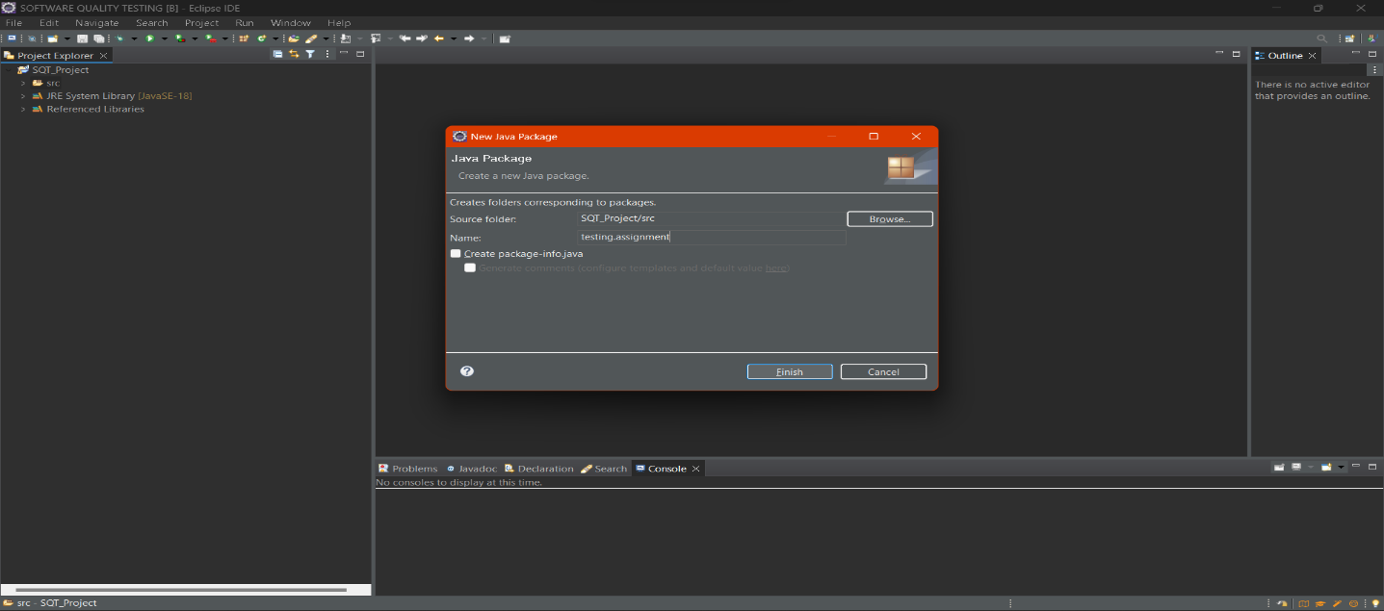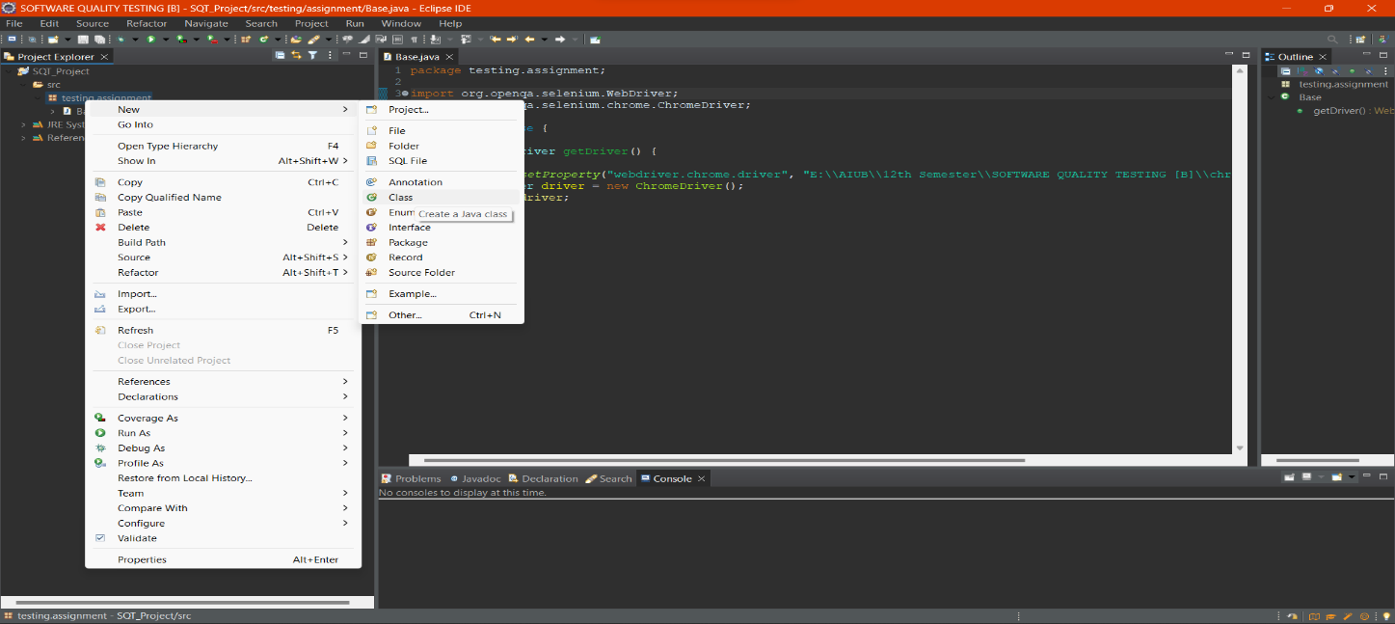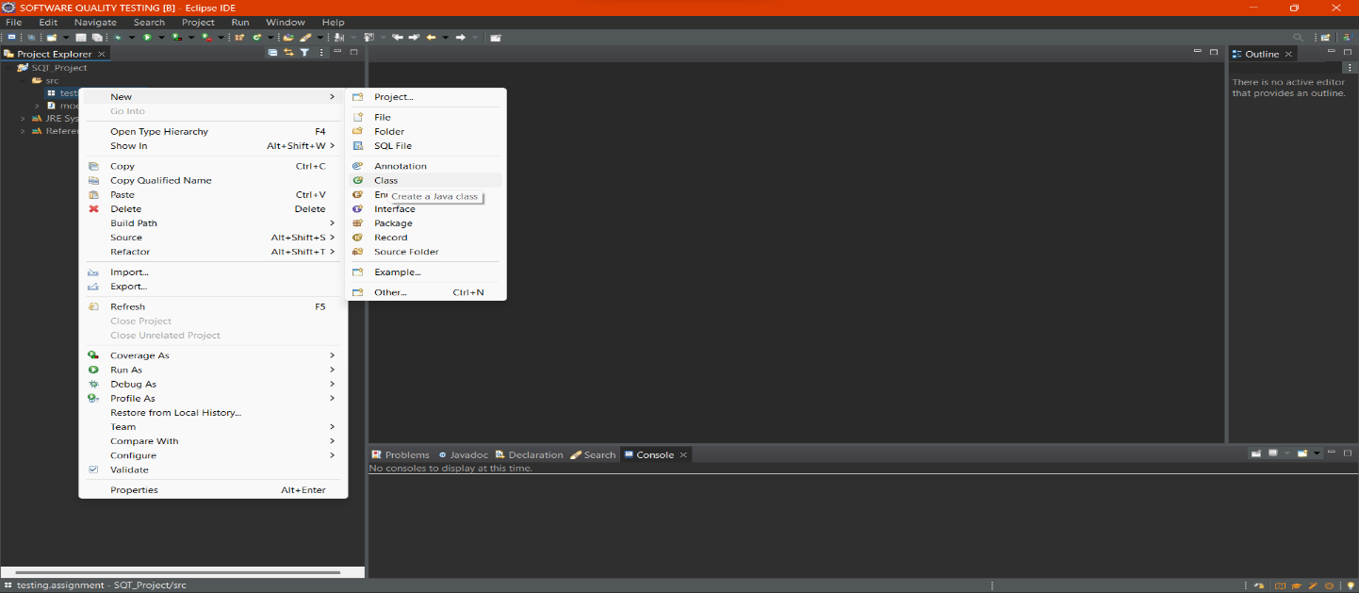

iv. Coding & Output:

